1. Implement the *validate* function so that it throws an error if called without arguments or an argument is undefined. Otherwise it should return the given value. The function should also be accessible from anywhere in a Browser HTML page js code(Global Scope).

*function validate(value) {*

*}*

1. Fix the bug in following HTML code :

*<!DOCTYPE html>*

*<html>*

*<head>*

*<meta charset="utf-8">*

*<title>Company page</title>*

*</head>*

*<body>*

*<paragraph>Welcome! Here you can find following things:</paragraph>*

*<ol>*

*<em><li><a href="#logo">Company's logo</a></li></em>*

*<li><a href="#employees">List of employees</a></li>*

*</ol>*

*<h1>Company's logo*

*<paragraph>Company uses following logos:</paragraph>*

*<ul>*

*<li>New logo:</li><img source="new_logo.gif"/>*

*<li>Old logo:</li><img source="old_logo.gif"/>*

*</ul>*

*<h1>List of employees*

*<thead>*

*<th>First name</th>*

*<th>Last name</th>*

*</thead>*

*<table>*

*<tr>*

*<td>Mary</td>*

*<td>Williams</td>*

*</tr>*

*<tr>*

*<td>James</td>*

*<td>Smith</td>*

*</tr>*

*</table>*

*</body>*

*</html>*

1. Create a form that looks exactly like below (Exactly same layout needs to be achieved).

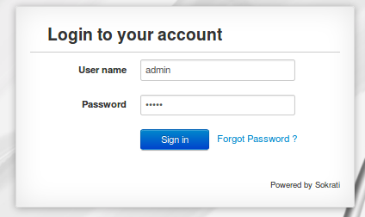

* Clicking on “Sign in” button should email the username and password to your email address.
* Clicking on “Forgot Password” should open a new tab in the browser with any url of your choice.
* Password field should not allow empty values, special characters or more than 8 characters to be entered.

1. Create the following layout in HTML and provide the functionality as described below

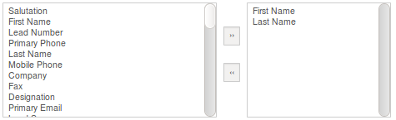

* Each item in the layout (Salutation, First Name etc should be selectable).
* Selecting an item from Box 1 and clicking on “>>” button should remove that item from Box 1 and move it to Box 2.
* Similarly, selecting an item from Box 2 and clicking on “<<” button should remove that item from Box 2 and move it to Box 1.
* You must use event listeners for achieving the functionality.
* Cross browser compatibility must be there.